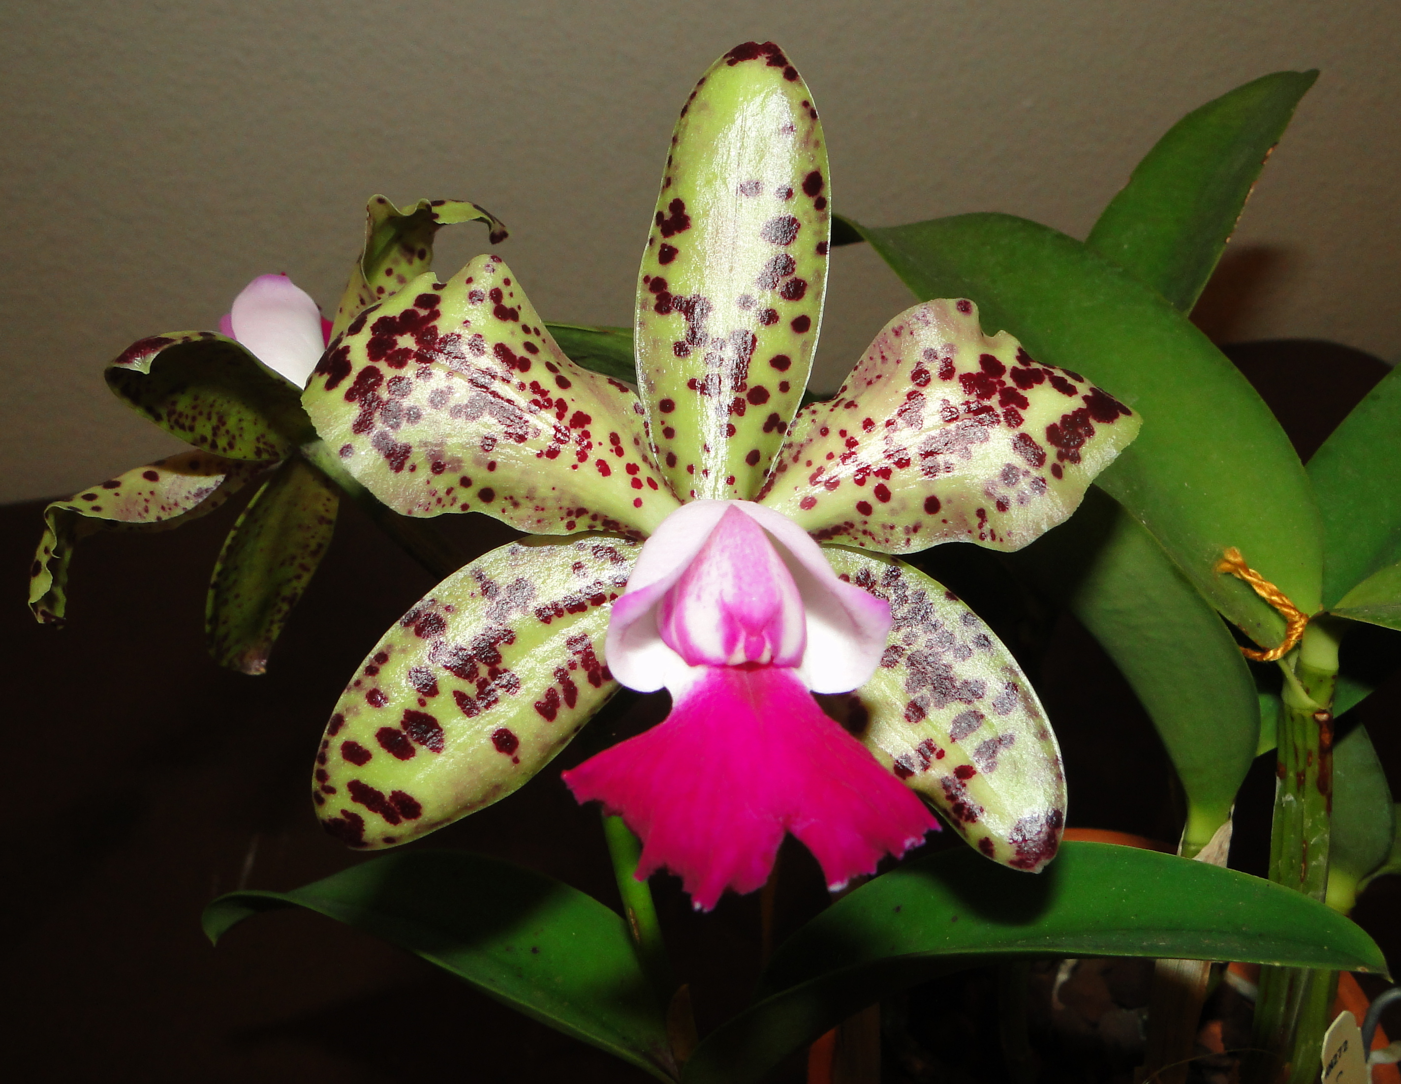
A joint meeting with the Englewood Area Orchid Society at the Christ Lutheran Church, 701 N. Indiana Ave., Englewood. Monday July 8th at 6:30 p.m.
Speaker: Paul Phelps
Topic: “Cattleya, Queen of Orchids”
Paul Phelps and his wife, Patricia, are the owners of Phelps Farm Orchids, Inc., a commercial orchid farm located on five acres in northwest Hillsborough County. Patricia’s love of orchids turned their hobby into a business in 1986 and their original 3500 sq. ft. greenhouse has doubled in size. A new 1600 sq. ft. greenhouse was recently added for their mounted plants.

Cattleyas are their specialty but you will find Bulbophyllum, Coelogyne, Dendrobium, Oncidium, Paphiopedilum, Phragmipedium, Phalaenopsis and Vandaceous Orchids, as well as assorted species and hybrids of other genera.

They began a breeding program in the late 80’s, with the main focus on the Cattleya alliance and Paul has developed more than 800 hybrids. Paul is a well-known speaker at local and regional orchid societies and Phelps Farm Orchids have been featured on NBC’s Daytime Show and the PBS series, America’s Heartland. Phelps Farm Orchids is open by appointment only Monday through Friday 9-5 and Saturday 9-12. Please call (813) 961-8427 for your appointment and visit their online catalog at www.phelpsfarm.com.

Paul’s motto has always been “Quality Plants at Reasonable Prices” and he will have a selection of his finest plants for sale.

